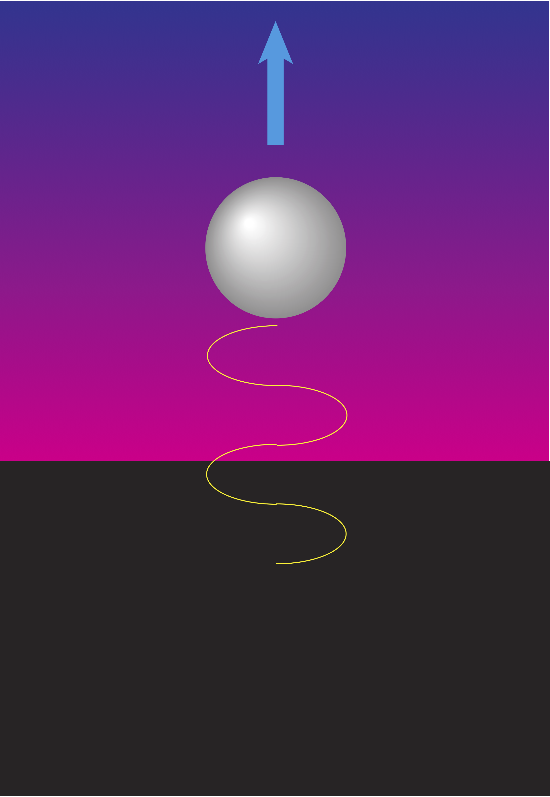

The non-relativistic velocity of an uncharged object emitting a photon
Imagine an uncharged object of mass m_{o} moving linearly through the vacuum of space with low initial velocity v_{o}. A moment later, the object emits a photon of momentum p from its surface. The object recoils in the opposite direction to the photon with a new velocity of v₁=v_{o}+dv. Assuming the mass of the object remains the same as before, what is the velocity v₁ after emission of the photon?
According to the principle of conservation of linear momentum, which states that "when no resultant external force [such as gravity or air friction] acts on a system, the total momentum of the system remains constant in magnitude and direction", the problem can be mathematically stated as:

m_{o}v_{o} + p = m_{o}v₁

or

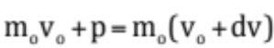

Rearranging terms gives,

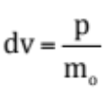

Formally integrating the differential term dv,

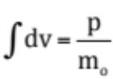

We get,

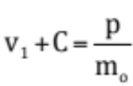

To determine C, we must realise just prior to the discrete emission of the photon (p = 0) that the object had a velocity v₁ equal to its initial velocity v_{o}. Therefore C = -v_{o} and so the non-relativistic recoil velocity for the object emitting just one photon is given by:

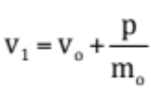

If the object happens to be the size of a tiny quantum uncharged particle such as a sodium atom, we can convert momentum p to show how the frequency f (or wavelength ) affects the speed of the particle.

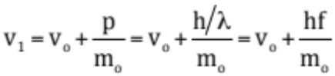

where h is Planck’s constant (in joules second).

Generally the higher the frequency (or shorter the wavelength), the greater the recoiling force of the radiation on the particle, and hence the faster the particle moves.

EXAMPLE
Suppose a sodium atom of mass m_{o} = 3.8 x 10⁻²⁶ kilogram, initially at rest (v_{o} = 0), emits a photon of wavelength λ= 5.89 x 10⁻⁷ metre. The recoil velocity of the atom is calculated as follows:

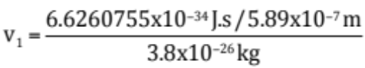

or

v₁ = 0.029 metres per second

Relativistic Considerations

The non-relativistic recoil velocity of an object of mass mo and initial velocity vo is given by:

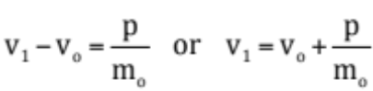

However, the laws of special relativity state that mass increases with speed. Let us rewrite the momentum equation above with this in mind. The principle of conservation of linear momentum for this system should be:

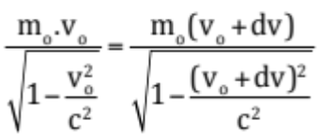

The final result after rearranging terms and integrating is as follows:

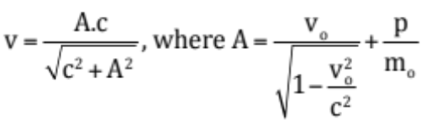
When initial velocity vo is zero, which means that just before a photon is emitted, the object is initially at rest, we obtain a rather pleasant equation to work with. Specifically:

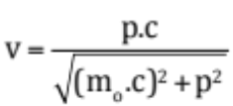

It should be remembered that while this formula focuses on one photon of emission to create movement in the uncharged object, one must not be restricted to just one photon emission at a time. It is possible for one end of the surface of the object to emit 10x photons per second, allowing the object to accelerate steadily at a rate which is dependent on the number and frequency of the photons. If we take this into consideration, the new equation for the recoil velocity of an object of mass mo initially at rest is given by:

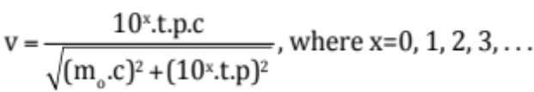

where t is the number of seconds that has elapsed while emitting 10x photons per second.

For the object to travel at reasonable speeds or at least have enough recoiling force to keep the object aloft in the air, it is envisaged that a powerful, lightweight laser system be incorporated into the object. This system will help to provide the required quantity and quality of the photons to be emitted (compared to just heating a metal which produces only about 5.5x108 photons per cubic centimetre at 300K and 2.0x1010 photons per cubic centimetre at 1000K.

And should the light beam be made to turn on-and-off continually at a high frequency rate, additional momentum will appear in the beam owing to the presence of the gravitational field (or higher energy density) to attract more electromagnetic energy from the environment and help increase the density of the emitted photons from the beam.
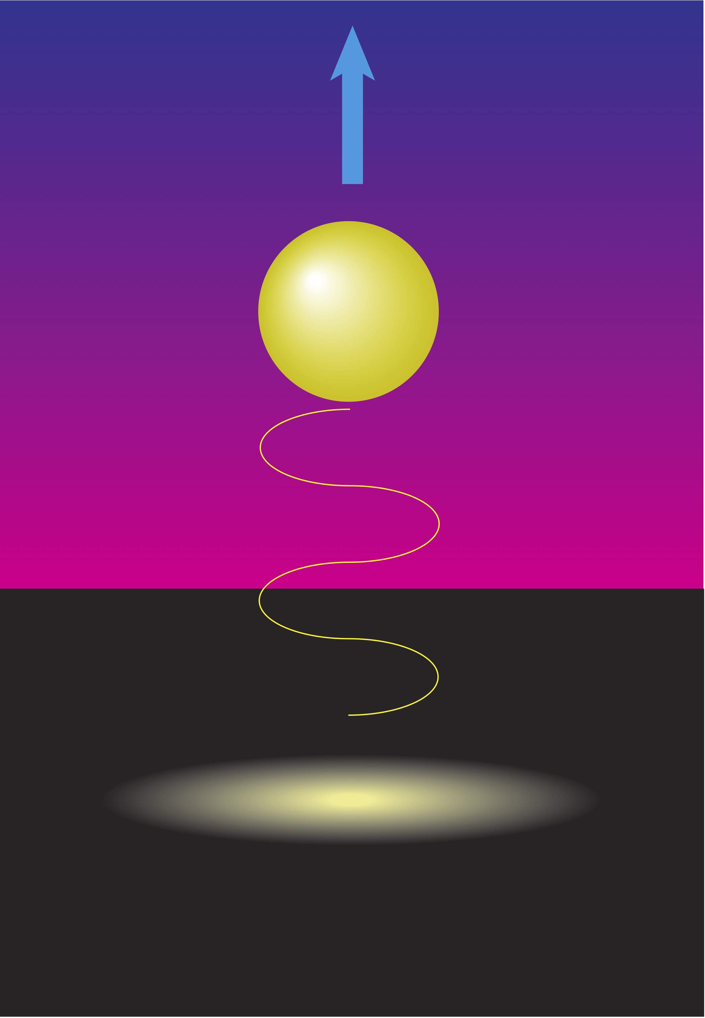

The non-relativistic velocity of a charged object emitting a photon

But what happens when the object is electrically charged? Instead of an uncharged object emitting just one photon at a time as it moves through space, a charged object accelerating through space is said to be emitting electromagnetic radiation continuously. And since the charge will increase speed after the emission of the radiation, the frequency and strength of the electromagnetic field in the radiation emitted by the charge will also increase. This subtle fact will undoubtably change the above equation for the uncharged case drastically.

In the words of Dr David J. Griffiths of the Department of Physics at Reed College, USA, who has studied the problem:

"According to the laws of classical electrodynamics, an accelerating charge radiates [electromagnetic energy]....The radiation evidently exerts a force back on the charge - a recoil force rather like that of a bullet on a gun...

The Abraham-Lorentz formula for [this] radiation reaction force...consistent with conservation of energy [is],

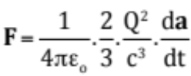

where Q is electric charge, a is acceleration (in vector notation), F is the force (in vector notation), t is time, c is the speed of light, and ε_{o} is the permittivity constant of free space.

Dr Griffiths also stated:

"...the Abraham-Lorentz formula has disturbing implications, which are not entirely understood 80 years after the law was first introduced."

The disturbing nature of the formula can be better appreciated when we solve the equation. If the charged object has mass m, then according to Newton’s second law of motion:

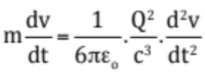

or

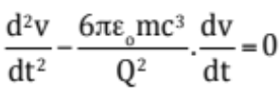

After solving this differential equation of the second order, we obtain:

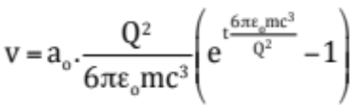

if we assume the charge Q is constant, then let’s simplify this solution by introducing the following constant:

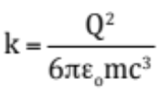

Thus the solution becomes,

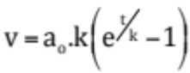

This is the non-relativistic recoil velocity of a charged object of mass m, charge Q and initial acceleration a_{o}. The acceleration of the charged object is, therefore:

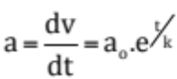

This equation implies a spontaneous exponential increase in the object’s acceleration over time t, even when no external force is applied.

Is this possible in reality?

EXAMPLE
Suppose an electron of mass m_{o} = 9.10939x10⁻³¹ kilogram and electric charge Q = 1.6021892x10⁻¹⁹ C, has an initial acceleration of 0.1 m.s⁻² as it emits a photon of a particular wavelength. The recoil velocity of the electron after t = 6.2 x 10⁻¹⁸ second is as follows:

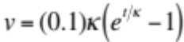

where 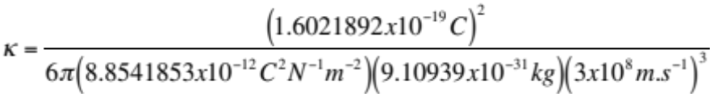

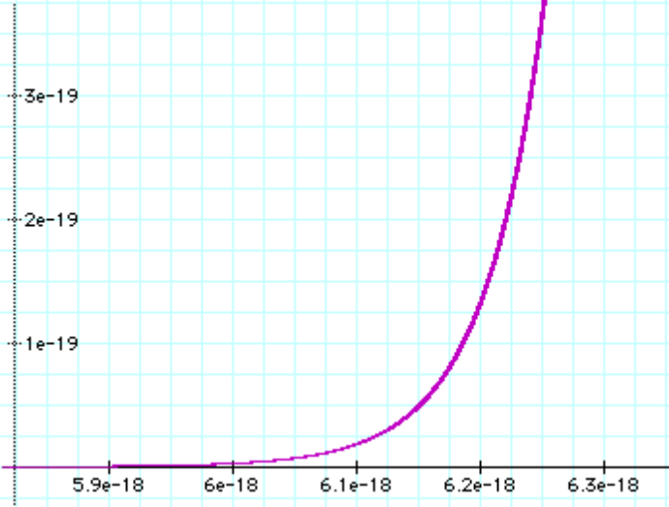

Or roughly v = 1.37 x 10⁻¹⁹ m.s⁻¹.

Slow at first, but give it a little more time while maintaining the charge and radiation emission and the velocity will quickly approach the speed of light. Increase the charge, and the initial build-up can be quickened.

NOTE: Another factor to affect acceleration and velocity is frequency. This is the last remaining term to be added to complete the solution.

As can be observed, the solution indicates dramatic acceleration due to the exponential term with no apparent means of slowing down the charged object’s motion (unless we switch off the electric charge, which for an electron is not possible). A number of scientists have been understandably amazed by the suggestion that any charged object at rest can undergo spontaneous and rather extraordinarily high speeds in a relatively short timeframe (i.e., approaching the speed of light) according to this solution. Yet we don't see this happen in the real world. Why don’t we see this in reality? What is the deciding factor that allows a charged object to self-accelerate?

To this day, scientists still believe it is too good to be true. There must be something wrong.

But is there?

Zemansky et al 1982, p.147.
Healy 1987, pp. 708-709

