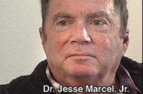

**AFFIDAVIT OF JESSE A. MARCEL JR.**</DIV> [1]<DIV align=center>

</DIV><DIV align=left>  
</DIV><DIV align=left>(1)  My name is Jesse A. Marcel, M.D.</DIV> <DIV align=left>

</DIV><DIV align=left>(2)  My address is:  XXXXXXXXXX</DIV> <DIV align=left>

</DIV><DIV align=left>(3)  I am a physician, and I have served in the National Guard since 1978; I am a certified crash investigator and helicopter pilot.</DIV> <DIV align=left>

</DIV><DIV align=left>(4)  In July 1947, I was eleven years old and lived in Roswell, New Mexico, where my father, Major Jesse Marcel, was stationed at the Roswell Army Air Field, serving as the base intelligence officer.</DIV> <DIV align=left>

</DIV><DIV align=left>(5)  One night, I was awakened by my father in the middle of the night.  He was very excited about some debris he had picked up in the desert.  The material filled up his 1942 Buick. He brought some of the material into the house, and we spread it out on the kitchen floor.</DIV> <DIV align=left>

</DIV><DIV align=left>(6)  There were three categories of debris: a thick, foil-like metallic gray substance; a brittle, brownish-black plastic-like material, like Bakelite; and there were fragments of what appeared to be I-beams.</DIV> <DIV align=left>

</DIV><DIV align=left>(7)  On the inner surface of the I-beam, there appeared to be a type of writing.  The writing was a purple-violet hue, and it had an embossed appearance.  The figures were composed of curved, geometric shapes.  It had no resemblance to Russian, Japanese or any other foreign language.  It resembled hieroglyphics, but it had no animnal-like characters.</DIV> <DIV align=left>

</DIV><DIV align=left>(8)  My father said the debris was recovered from a crash site northwest of Roswell.  He felt it was very unusual and may have mentioned the words "flying saucer" in connection with the material.  He was certain it was not from a weather balloon.</DIV> <DIV align=left>

</DIV><DIV align=left>(9)  I have not been paid or given anything of value to make this statement, which is the truth to the best of my recollection.</DIV> <DIV align=left>

</DIV><DIV align=left>Signed:  Jesse A. Marcel</DIV> <DIV align=left>6 Mar 91</DIV> <DIV align=left>

</DIV><DIV align=left>Signature witnessed by:</DIV> <DIV align=left>Trudy Anders LPN</DIV> <DIV align=left>

**Drawing of "I-Beam"**</DIV> <DIV align=left>

</DIV><DIV align=left>Jesse A Marcel, M.D., P.C.</DIV> <DIV align=left>  
</DIV><DIV align=left>Fellow, American Academy of Otolaryngology -- Head and Neck Surgery</DIV> <DIV align=left>  
</DIV><DIV align=left>  
</DIV><DIV align=left>Dear Mr. Solomon:</DIV> <DIV align=left>

The following is a general description of the fragment that had what appeared to have a form of writing on its surface.</DIV> <DIV align=left>

</DIV><DIV align=left>          There was a series of geometric patterns embossed on the inner surface of a fragment shaped like an "I" beam strut.  There were no recognizable animal figures such as seen in Egyption hieroglyphics but the symbols resembled heiroglyphic type characters.</DIV> <DIV align=left>

</DIV><DIV align=left>          Most of the debris looked like pieces of an aircraft airframe and its skin.  Some of the debris was not metallic but more like pieces of black plastic fragments thicker than the metallic skin.</DIV> <DIV align=left>

</DIV><DIV align=left>          The color of the symbols was of a violet or purplish metallic hue.

Obviously the above symbols are not an exact duplication, but this is more or less what they looked like as I can recall after more than forty years.</DIV> <DIV align=left>  
</DIV><DIV align=left>  
</DIV><DIV align=left>                                                                                                    Sincerely,</DIV> <DIV align=left>  
</DIV><DIV align=left>  
</DIV><DIV align=left>  
</DIV><DIV align=left>                                                                                                    Jess Marcel</DIV> <DIV align=left>  
</DIV><DIV align=left>  
</DIV><DIV align=left>PS  I showed the above drawing to my mother who was also present and she </DIV><DIV align=left>concurs with the above description.



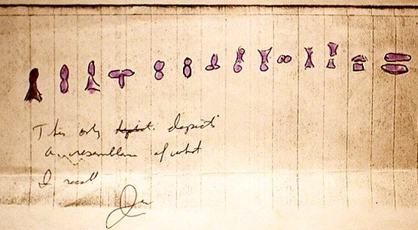

1. Karl Pflock, *Roswell in Perspective*, 1994.