**­­RAAF Captures Flying Saucer On Ranch**

**in Roswell Region**

**No Details of Flying Disk Are Revealed**

**Roswell Hardware Man and Wife Report Disk Seen**

*Roswell Daily Record*, Tuesday 8 July 1947

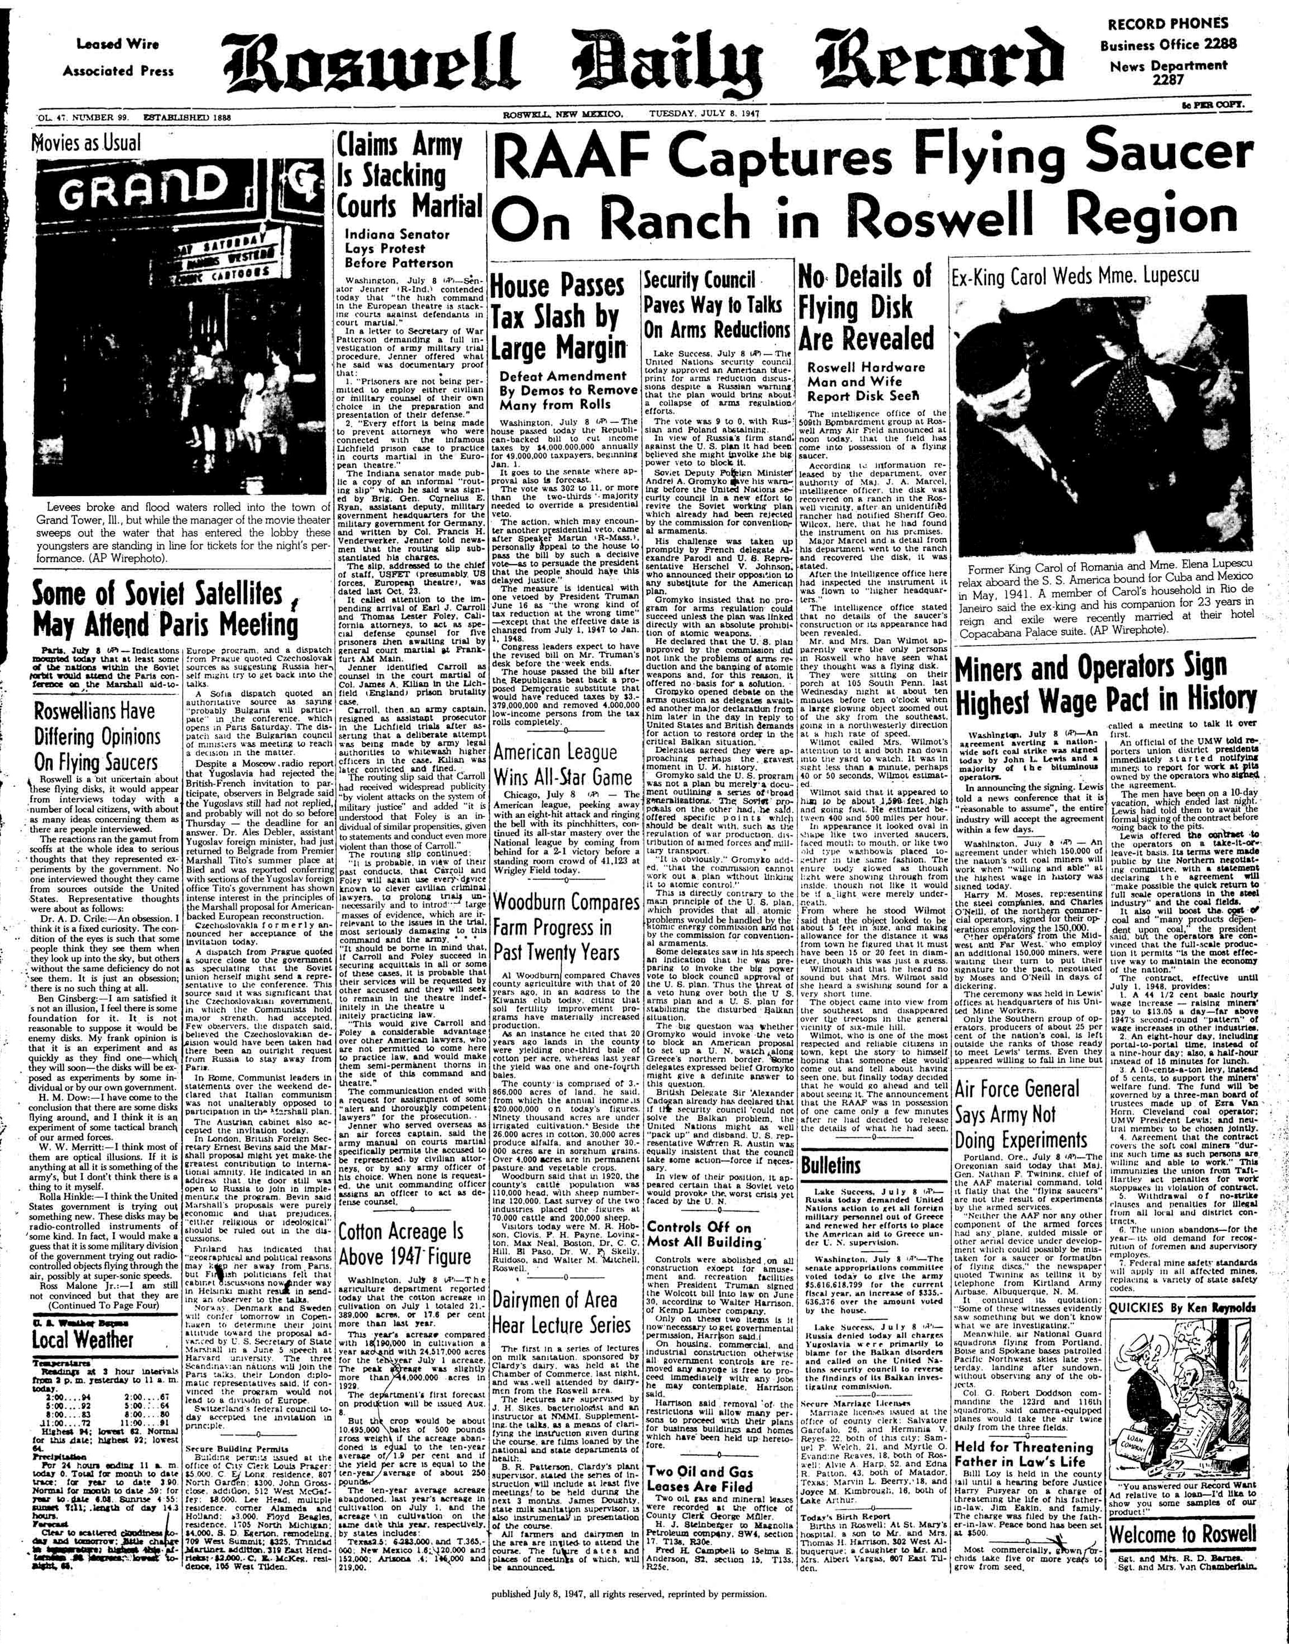

------------------------------------------------------------------------------------------------------

The intelligence office of the 509th Bombardment group at Roswell Army Air Field announced at noon today, that the field has come into possession of a flying saucer.

According to information released by the department, over authority of Maj. J. A. Marcel, intelligence officer, the disk was recovered on a ranch in the Roswell vicinity, after an unidentified rancher had notified Sheriff Geo. Wilcox, here, that he had found the instrument on his premises.

Major Marcel and a detail from his department went to the ranch and recovered the disk, it was stated.

After the intelligence officer here had inspected the instrument it was flown to higher headquarters.

The intelligence office stated that no details of the saucer's construction or its appearance had been revealed.

Mr. and Mrs. Dan Wilmot apparently were the only persons in Roswell who saw what they thought was a flying disk.

They were sitting on their porch at 105 South Penn. last Wednesday night at about ten o'clock when a large glowing object zoomed out of the sky from the southeast, going in a northwesterly direction at a high rate of speed.

Wilmot called Mrs. Wilmot's attention to it and both ran down into the yard to watch. It was in sight less then a minute, perhaps 40 or 50 seconds, Wilmot estimated.

Wilmot said that it appeared to him to be about 1,500 feet high and going fast. He estimated between 400 and 500 miles per hour.

In appearance it looked oval in shape like two inverted saucers, faced mouth to mouth, or like two old type washbowls placed, together in the same fashion. The entire body glowed as though light were showing through from inside, though not like it would inside, though not like it would be if a light were merely underneath.

From where he stood Wilmot said that the object looked to be about 5 feet in size, and making allowance for the distance it was from town he figured that it must have been 15 to 20 feet in diameter, though this was just a guess.

Wilmot said that he heard no sound but that Mrs. Wilmot said she heard a swishing sound for a very short time.

The object came into view from the southeast and disappeared over the treetops in the general vicinity of six mile hill.

Wilmot, who is one of the most respected and reliable citizens in town, kept the story to himself hoping that someone else would come out and tell about having seen one, but finally today decided that he would go ahead and tell about it. The announcement that the RAAF was in possession of one came only a few minutes after he decided to release the details of what he had seen.

**Gen. Ramey Empties Roswell Saucer**

**Ramey Says Excitement is Not Justified**

**General Ramey Says Disk is Weather Balloon**

*Roswell Daily Record*, Wednesday 9 July 1947

1947 1

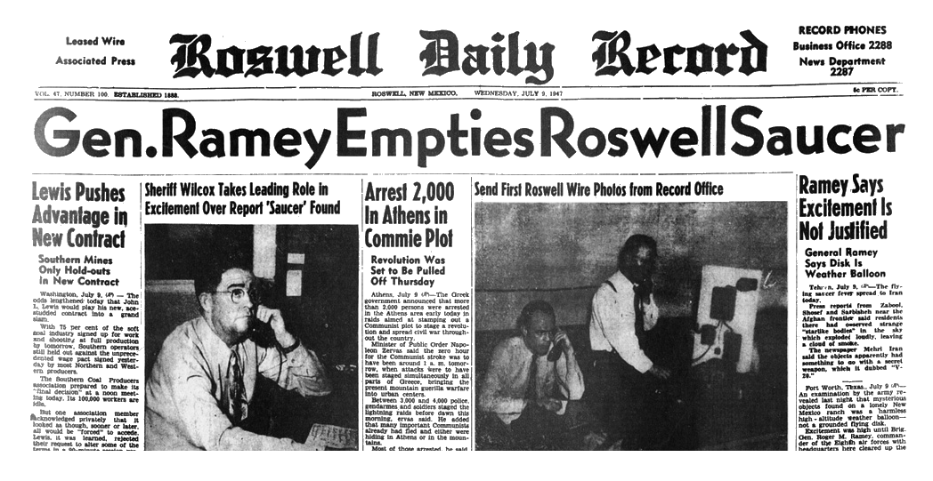

------------------------------------------------------------------------------------------------------

Fort Worth, Texas, July 9 (AP) An examination by the army revealed last night that mysterious objects found on a lonely New Mexico ranch was a harmless high-altitude weather balloon - not a grounded flying disk. Excitement was high until Brig. Gen. Roger M. Ramey, commander of the Eighth air forces with headquarters here cleared up the mystery.

The bundle of tinfoil, broken wood beams and rubber remnants of a balloon were sent here yesterday by army air transport in the wake of reports that it was a flying disk.

But the general said the objects were the crushed remains of a ray wind target used to determine the direction and velocity of winds at high altitudes.

Warrant Officer Irving Newton, forecaster at the army air forces weather station here said, "we use them because they go much higher than the eye can see."

The weather balloon was found several days ago near the center of New Mexico by Rancher W. W. Brazel. He said he didn't think much about it until he went into Corona, N. M., last Saturday and heard the flying disk reports.

He returned to his ranch, 85 miles northwest of Roswell, and recovered the wreckage of the balloon, which he had placed under some brush.

Then Brazel hurried back to Roswell, where he reported his find to the sheriff's office.

The sheriff called the Roswell air field and Maj. Jesse A. Marcel, 509th bomb group intelligence officer was assigned to the case.

Col. William H. Blanchard, commanding officer of the bomb group, reported the find to General Ramey and the object was flown immediately to the army air field here.

Ramey went on the air here last night to announce the New Mexico discovery was not a flying disk.

Newton said that when rigged up, the instrument "looks like a six-pointed star, is silvery in appearance and rises in the air like a kite."

In Roswell, the discovery set off a flurry of excitement.

Sheriff George Wicox's telephone lines were jammed. Three calls came from England, one of them from The London Daily Mail, he said.

A public relations officer here said the balloon was in his office "and it'll probably stay right there."

Newton, who made the examination, said some 80 weather stations in the U. S. were using that type of balloon and that it could have come from any of them.

He said he had sent up identical balloons during the invasion of Okinawa to determine ballistics information for heavy guns.

**Harassed Rancher Who Located 'Saucer'**

**Sorry He Told About It**

*Roswell Daily Record*, Wednesday 9 July 1947



------------------------------------------------------------------------------------------------------

W. W. Brazel, 48, Lincoln county rancher living 30 miles south of Corona, today told his story of finding what the army at first described as a flying disk, but the publicity which attended his find caused him to add that if he ever found anything else short of a bomb, he sure wasn't going to say anything about it.

Brazel was brought here late yesterday by W. E. Whitmore, of radio station KGFL, had his picture taken and gave an interview to the Record and Jason Kellahin, sent here from the Albuquerque bureau of the Associated Press to cover the story. The picture he posed for was sent out over AP telephoto wire sending machine specially set up in the Record office by R. D. Adair, AP wire chief sent here from Albuquerque for the sole purpose of getting out his picture and that of sheriff George Wilcox, to whom Brazel originally gave the information of his find.

Brazel related that on June 14 he and an 8-year old son, Vernon, were about 7 or 8 miles from the ranch house of the J. B. Foster ranch, which he operates, when they came upon a large area of bright wreckage made up of rubber strips, tinfoil, a rather tough paper and sticks.

At the time Brazel was in a hurry to get his round made and he did not pay much attention to it. But he did remark about what he had seen and on July 4 he, his wife, Vernon and a daughter, Betty, age 14, went back to the spot and gathered up quite a bit of the debris.

The next day he first heard about the flying disks, and he wondered if what he had found might be the remnants of one of these.

Monday he came to town to sell some wool and while here he went to see sheriff George Wilcox and "whispered kinda confidential like" that he might have found a flying disk.

Wilcox got in touch with the Roswell Army Air Field and Maj. Jesse A. Marcel and a man in plain clothes accompanied him home, where they picked up the rest of the pieces of the "disk" and went to his home to try to reconstruct it.

According to Brazel they simply could not reconstruct it at all. They tried to make a kite out of it, but could not do that and could not find any way to put it back together so that it could fit.

Then Major Marcel brought it to Roswell and that was the last he heard of it until the story broke that he had found a flying disk.

Brazel said that he did not see it fall from the sky and did not see it before it was tom up, so he did not know the size or shape it might have been, but he thought it might have been about as large as a table top. The balloon which held it up, if that was how ft worked, must have been about 12 feet long, he felt, measuring the distance by the size of the room in which he sat. The rubber was smoky gray in color and scattered over an area about 200 yards in diameter.

When the debris was gathered up the tinfoil, paper, tape, and sticks made a bundle about three feet long and 7 or 8 inches thick, while the rubber made a bundle about 18 or 20 inches long and about 8 inches thick. In all, he estimated, the entire lot would have weighed maybe five pounds.

There was no sign of any metal in the area which might have been used for an engine and no sign of any propellers of any kind, although at least one paper fin had been glued onto some of the tinfoil.

There were no words to be found anywhere on the instrument, although there were letters on some of the parts. Considerable scotch tape and some tape with flowers printed upon it had been used in the construction.

No strings or wire were to be found but there were some eyelets in the paper to indicate that some sort of attachment may have been used.

Brazel said that he had previously found two weather observation balloons on the ranch, but that what he found this time did not in any way resemble either of these.

"I am sure that what I found was not any weather observation balloon," he said. "But if I find anything else besides a bomb they are going to have a hard time getting me to say anything about it.”