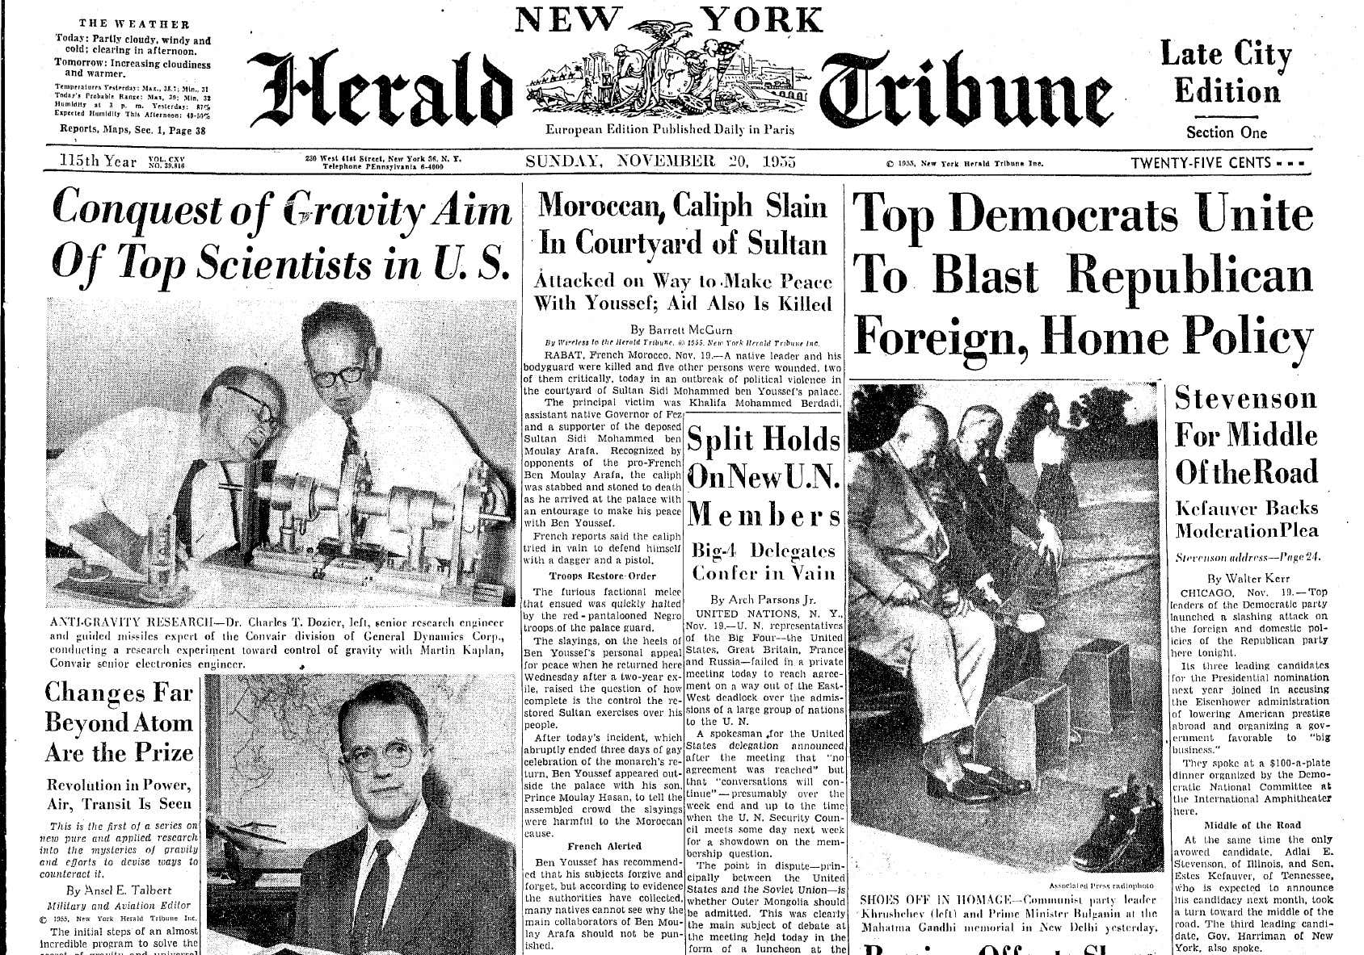
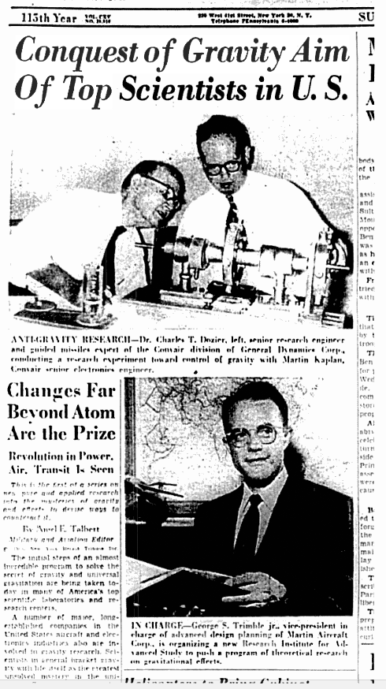
Conquest of Gravity Aim of Top Scientists in U.S.
By
Ansel E. Talbert, Military and Aviation Editor

ANTI-GRAVITY RESEARCH - Dr. Charles T. Dozier, left, senior research engineer and guided missiles expert of the Convair Division of General Dynamics Corp., conducting a research experiment toward control of gravity with Martin Kaplan, Convair Senior electronics engineer.

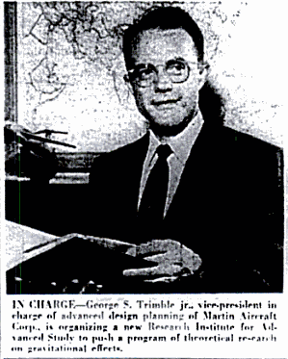

IN CHARGE - George S. Trimble jr, vice-president in charge of advanced design planning of Martin Aircraft Corp., is organizing a new research institute for advanced study to push a program of theoretical research on gravitational effect

CHANGES FAR BEYOND THE ATOM ARE THE PRIZE
Revolution in Power, Air, Transit Is Seen

This is the first of a series on new pure and applied research into the mysteries of gravity and efforts to devise ways to counteract it. Written by Ansel E. Talbert, military and aviation editor, N.Y.H.T.

The initial steps of an almost incredible program to solve the secret of gravity and universal gravitation are being taken today in many of America's top scientific laboratories and research centres. A number of major, long-established companies in the United States aircraft and electronics industries also are involved in gravity research. Scientists, in general, bracket gravity with life itself as the greatest unsolved mystery in the Universe. But there are increasing numbers who feel that there must be a physical mechanism for its propagation which can be discovered and controlled.

Should this mystery be solved it would bring about a greater revolution in power, transportation and many other fields than even the discovery of atomic power. The influence of such a discovery would be of tremendous import in the field of aircraft design -where the problem of fighting gravity's effects has always been basic.

A FANTASTIC POSSIBILITY

One almost fantastic possibility is that if gravity can be understood scientifically and negated or neutralized in some relatively inexpensive manner, it will be possible to build aircraft, earth satellites, and even space ships that will move swiftly into outer space, without strain, beyond the pull of earth's gravity field. They would not have to wrench themselves away through the brute force of powerful rockets and through expenditure of expensive chemical fuels.

Centres where pure research on gravity now is in progress in some form include the Institute for Advanced Study at Princeton, N.J. and also at Princeton University: the University of Indiana's School of Advanced Mathematical Studies and the Purdue University Research Foundation.

A scientific group from the Massachusetts Institute of Technology, which encourages original research in pure and applied science, recently attended a seminar at the Roger Babson Gravity Research Institute of New Boston, N.H., at which Clarence Birdseye, inventor and industrialist, also was present. Mr. Birdseye gave the world its first packaged quick-frozen foods and laid the foundation for todays frozen food Industry: more recently he has become interested in gravitational studies.

A proposal to establish at the University of North Carolina at Chapel Hill, N.C., an 'Institute of Pure Physics' primarily to carry on theoretical research on gravity was approved earlier this month by the University's board of trustees. This had the approval of Dr. Gordon Gray who has since retired as president of the University. Dr. Gray has been Secretary of the Army, Assistant Secretary of Defence, and special assistant to the President of the United States.

FUNDS COLLECTED

Funds to make the institute possible were collected by Agnew H. Bahnson jr., an industrialist of Winston Salem, N.C. The new University of North Carolina administration is now deciding on the institute's scope and personnel. The directorship has been offered to Dr. Bryce S. Dewitt of the Radiation Laboratories at the University of California at Berkeley, who is the author of a Roger Babson prize-winning scientific study entitled, 'New Directions for Research in the Theory of Gravity.'

The same type of scientific disagreement which occurred in connection with the first proposals to build the hydrogen bomb and an artificial earth satellite -now under construction -is in progress over anti-gravity research. Many scientists of repute are sure that gravity can be overcome in comparatively few years if sufficient resources are put behind the project. Others believe it may take a quarter of a century or more.

REFUSE TO PREDICT

Some pure physicists, while backing the general program to try to discover how gravity is propagated, refuse to make predictions of any kind. Aircraft industry firms now participating or actively interested in gravity include Glenn L. Martin Co. of Baltimore, builders of the nation's first giant jet-powered flying boat; Convair of San Diego, designers and builders of the giant B-36 intercontinental bomber and the world's first successful vertical take-off fighter; Bell Aircraft of Buffalo, builders of the first piloted airplane to fly faster than sound and a current jet take-off and landing airplane, and Sikorsky Division of United Aircraft, pioneer helicopter builders.

Lear, Inc., of Santa Monica, one of the world's largest builders of automatic pilots for airplanes; Clarke Electronics of Palm Springs, California, a pioneer in its field, and the Sperry Gyroscope Division of Sperry-Rand Corp., of Great Neck, L.I., which is doing important work on guided missiles and earth satellites, also have scientists investigating the gravity problem.

USE EUROPEAN EXPERT

Martin Aircraft has just put under contract one of Europe's leading theoretical authorities on gravity and electromagnetic fields -Dr. Burkhard Heim of Goettingen University where some of the outstanding discoveries of the century in aerodynamics and physics have been made, and Dr. Pascual Jordan of Hamburg University, Max Planck Medal winner whose recent work called 'Gravity and the Universe' has excited scientific circles throughout the world.

Dr. Heim, now professor of theoretical physics at Goettingen, and who was a member of Germany's Bureau of Standards during World War II, is certain that gravity can be overcome. Dr. Heim lost his eyesight and hearing, and had both arms blown off at the elbow in a World War II rocket explosion. He dictates his theories and mathematical calculations to his wife.

Martin Aircraft, at the suggestion of George S. Trimble, its vice-president in charge of advanced design planning, is building between Washington and Baltimore a new laboratory for the Research Institute for Advanced Study... A theoretical investigation of the implications for future gravity research in the 'United Field Theory' of the late Dr. Albert Einstein is now underway here.

Although financed by Martin, the Institute will have no connection with the day-to-day business of building airplanes. Its general manager is Welcome Bender.

Up to now no scientist or engineer -so far as is known in the scientific circles -has produced the slightest alteration in the magnitude or direction of gravitational 'force' although many cranks and crackpots have claimed to be able to do this with 'perpetual motion machines.'

NO ACCEPTED THEORY

There is no scientific knowledge or generally accepted theory about the speed with which it travels across interplanetary space, making any two material particles or bodies -if free to move -accelerate toward each other. But the current efforts to understand gravity and universal gravitation both at sub-atomic level and at the level of the Universe have the positive backing today of many of America's outstanding physicists.

These include Dr. Edward Teller of the University of California, who received prime credit for developing the hydrogen bomb; Dr. J. Robert Oppenheimer, director of the Institute for Advanced Study at Princeton; Dr. Freeman J. Dyson, theoretical physicist at the Institute, and Dr. John A. Wheeler, professor of physics at Princeton University who made important contributions to America's first nuclear fission project.

PURE RESEARCH VIEW

It must be stressed that scientists in this group approach the problem only from the standpoint of pure research. They refuse to predict exactly in what directions the search will lead or whether it will be successful beyond broadening human knowledge generally.

Other top-ranking scientific minds being brought to bear today on the gravity problem are those of Dr. Vaclav Hlavaty, of the University of Indiana, who served with Dr. Einstein on the faculty of Charles University in Prague and later taught advanced mathematics at the Sorbonne in Paris; and of Dr. Stanley Deser and Dr. Richard Arnowitt of the Princeton Institute for Advanced Study.

Dr. Hlavaty believes that gravity simply is one aspect of electromagnetism -the basis of all cosmic forces and eventually may be controlled like light and radio waves.

HOPE TO FIND KEY

Dr. Deser and Dr. Arnowitt are of the opinion that very recently discovered nuclear and sub-nuclear particles of high energy which are difficult to explain by any present-day theory, may prove to be the key that eventually unlocks the mystery. It is their suggestion that the new particles may prove to be basic gravitational energy which is being converted continually and automatically in an expanding Universe directly into the most useful nuclear and electromagnetic forms.' In a recent scientific paper they point out:

'One of the most hopeful aspects of the problem is that until recently gravitation could be observed but not experimented on in any controlled fashion, while now with the advent in the past two years of the new high-energy accelerators (the Cosmotron and the even more recent Berkeley Bevatron) the new particles which have been linked with the gravitational field can be examined and worked with at will .'

An important job of encouraging both pure and applied gravity research in the United States through annual prizes and seminars as well as, the summarizing of new research for engineers and scientists in industry looking forward to a real 'hardware solution' to the gravity problem is being performed by the Gravity Research Foundation of New Boston, N.H.

This was founded and endorsed by Dr. Roger Babson, economist, who is an alumnus of M.I.T. and a lifelong student of the works of Sir Isaac Newton, discoverer of gravity. Its president is Dr. George Rideout of Boston.

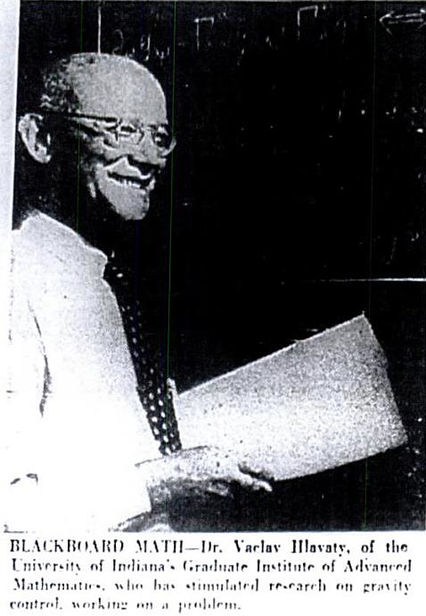

BLACKBOARD MATH - Dr. Vaclav Hlavaty, of the University of Indiana's graduate Institute of Advanced Mathematics, who has stimulated research on gravity control, working on a problem.

[PICTURE]

ANTI-GRAVITY AND AVIATION - George S. Trimble jr. vice-president in charge of advanced design planning of Martin Aircraft Corp., left discussing the application of anti-gravitational research to aviation with two Martin scientists, J.D. Pierson, center, and William B. Yates.

Source: NEW YORK HERALD-TRIBUNE: Sunday, November 20, 1955 pp. 1 & 36

